**LAB ASSIGNMENT-9.1**

**Name:**P.Navya

**HTNO:**2403A51331

**Batch:**13

**Task-1:**

Use AI to add Google-style docstrings to all functions in a  
given Python script.

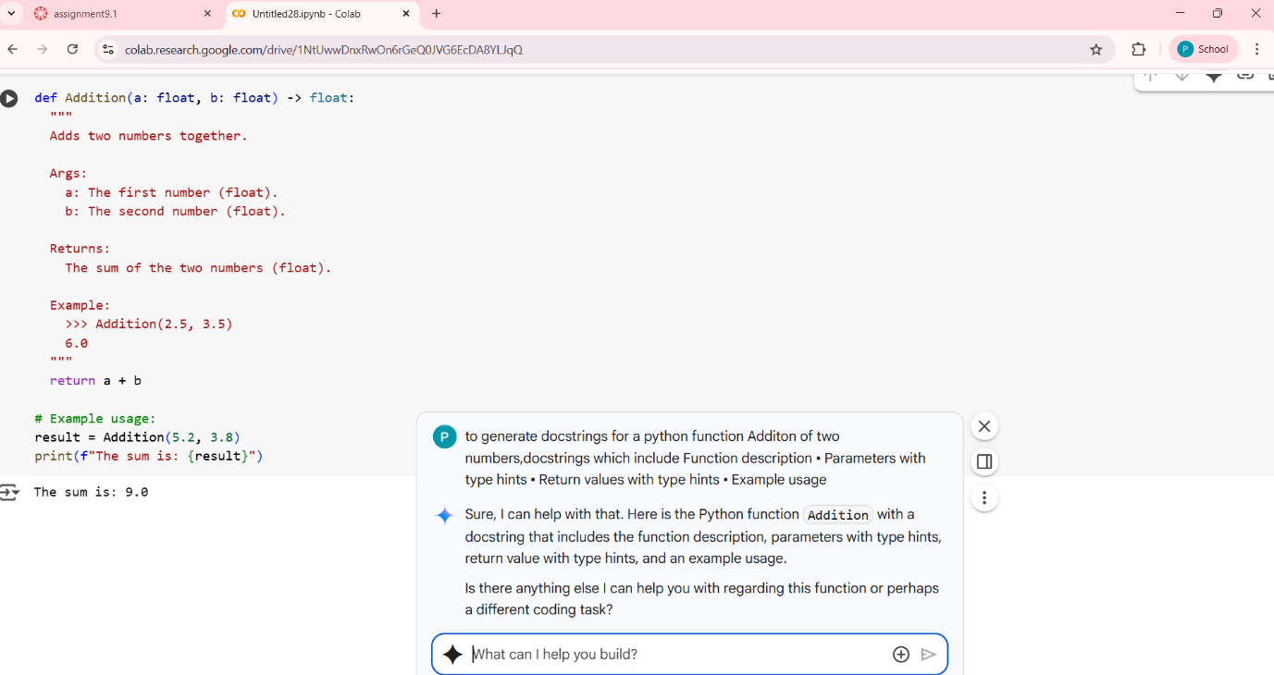

**TASK-2:**

Use AI to add meaningful inline comments to a Python  
program explaining only complex logic parts

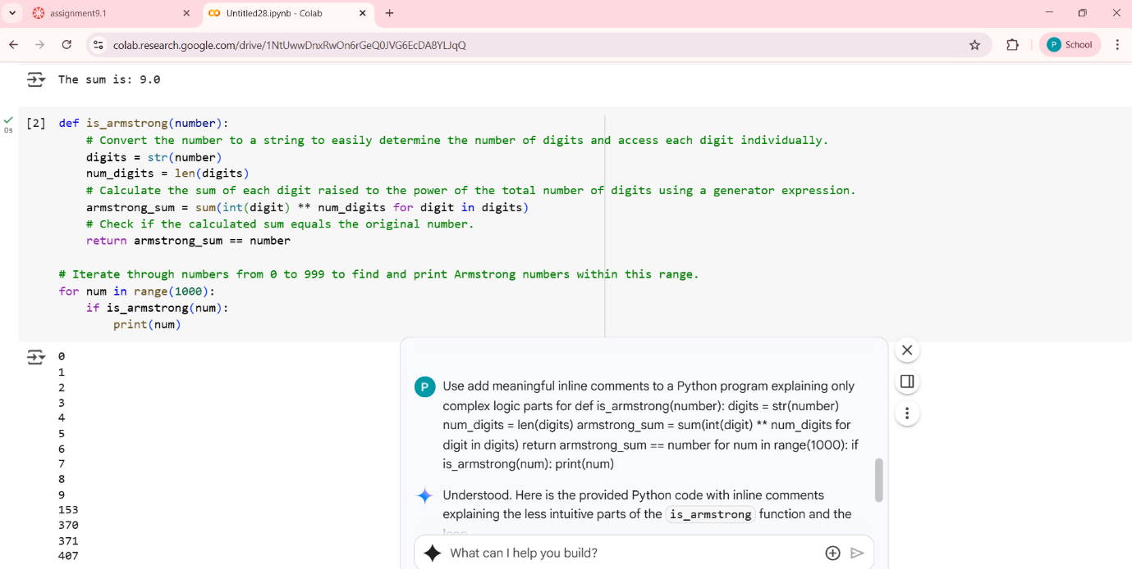

**TASK-3:**Use AI to create a module-level docstring summarizing the  
purpose, dependencies, and main functions/classes of a Python  
file.

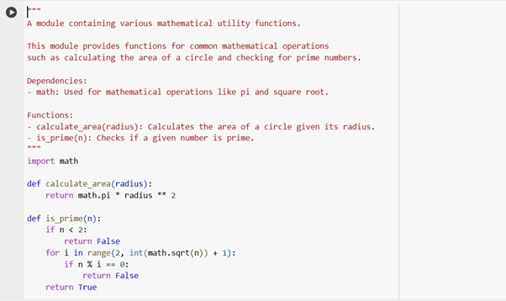

**TASK-4:**

Use AI to transform existing inline comments into  
structured function docstrings following Google style

**Python function with inline comments**

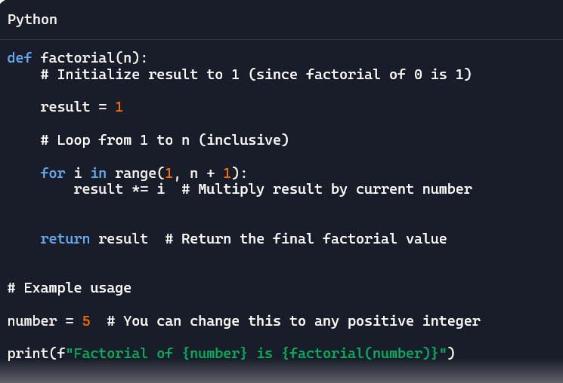

**Python function with inline comments converted into docstrings**

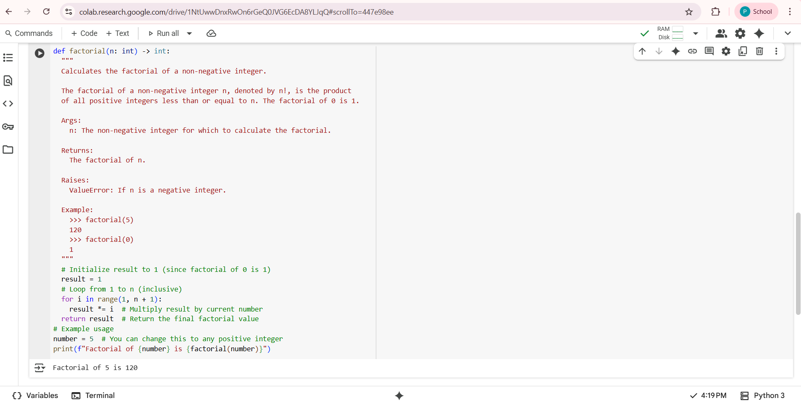

**Task-5:**

Use AI to identify and correct inaccuracies in existing  
docstrings

**A pthyon code with inaccuracies**

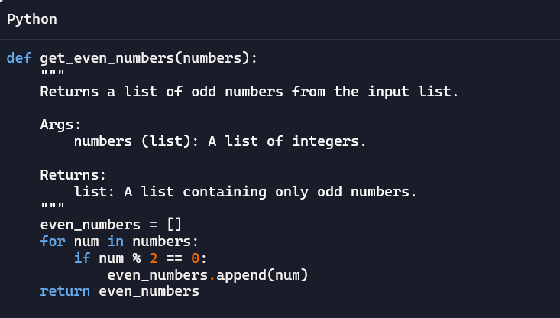

**Correcting inaccuracies in the above code**

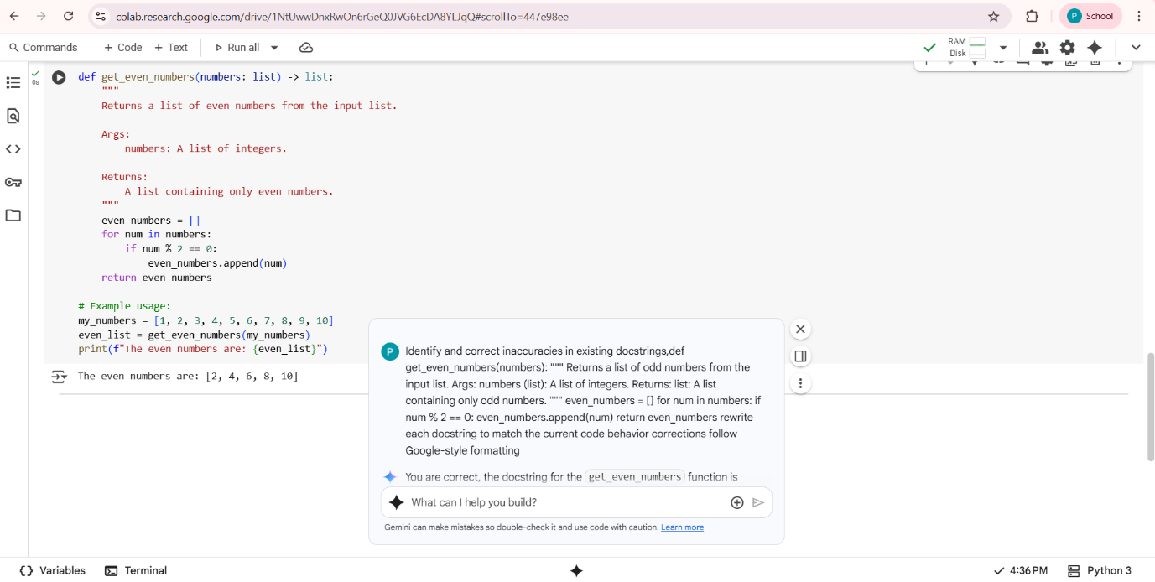

**TASK-6:**

Compare documentation output from a vague prompt and a  
detailed prompt for the same Python function

**simple python function by Adding comments to this function**

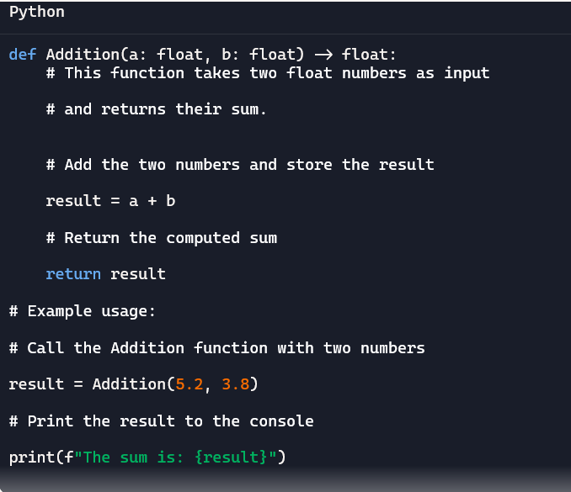

**Google-style documentation format(detailed prompt):**



**Comparisionn detailed prompt and vague prompt**

| **Feature** | **Generated Docstring** | **Inline Comments** |
| --- | --- | --- |
| **Quality** | High (Standardized format, parsable by tools) | Lower (Dispersed, not standardized) |
| **Accuracy** | High (Describes purpose, args, return, example) | High (Describes specific code steps) |
| **Completeness** | High (Includes description, args, return, example) | Lower (Explains steps, lacks overall function overview) |
| **Purpose** | Formal function/API documentation | Explaining specific code logic to readers of the code |